TRABAJO PRACTICO RECUPERATORIO
TURNO: Vespertino
MATERIA: LENGUA EXTRANEJRA INGLÉS
CURSO: 1ro DIVISIÓN: PRIMERA
Semana: Del 17-02-21 al 23-02-21
Prof.: Cinthya Fernández Curso: 1ª Div.: 1ª E-mail: veritocin77@gmail.com Turno: Vespertino
Datos a completar por el alumno
APELLIDO Y NOMBRE:
CURSO: DIVISIÓN: TURNO:
E-MAIL:
TELÉFONO: (SEÑALAR: FIJO O MÓVIL)

1- WRITE THE MISSING NUMBERS. (ESCRIBE LOS NÚMEROS QUE FALTAN)
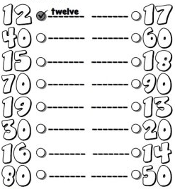

2- Complete the questions. Answer. Personal information. (Completa las preguntas. Responde. Información personal)
a- _______ is your name?
b- What _____ ________ surname?
c- ____ old _____ you?
d- _______ are ______ from?
e- _______ _____ your nationality?
f- _______ is ______ cell phone number?
g- ______ _____ your favourite colour?
3- Fill in the blanks with “am/is/are”. 4- Rewrite the sentences in the negative.
(Completa con “am/is/are”) (Reescribe las oraciones en forma negativa)
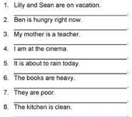
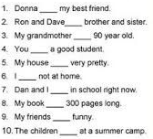

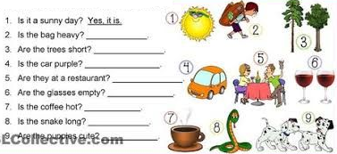
4- Look at the pictures. Write short answers. (Mira las imágenes. Escribe respuestas cortas.)

5- Oral activity. Give the personal information of a friend or family member. Use “He/She” and “His/Her”. (Actividad oral. Dar la información personal de un amigo/a o familiar. Usar “He/She/His/Her”)
EXAMPLE:
ANA IS MY MOTHER . HER SURNAME IS VILTE . SHE IS 65 YEARS OLD.

6- Look at the picture. Write 10 (ten) sentences describing the bedroom. Use “there is /there isn´t /there are /there aren´t” and prepositions: on, next to, in front of, etc. (Mira la imagen. Escribe 10 oraciones describiendo el dormitorio. Usa “there is /there isn´t /there are /there aren´t” y preposiciones)
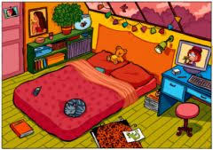
EXAMPLE:
THERE IS A PICTURE ON THE WALL.
THERE ISN´T A MIRROR NEXT TO THE DOOR.

