TP DE RECUPERACION FEBRERO /2021
TURNO:TARDE
MATERIA: INGLÉS
CURSO: 4TO DIVISIÓN: 1°
Nombre y Apellido del alumno/a: ………………………….............. Curso y Turno: ……………..
FECHA DE PRESENTACION: SEMANA DEL 10/02/2021 AL 12/02/2021
FECHA DE DEFENSA ORAL DEL TRABAJO PRACTICO: : MARTES 23 DE FEBRERO DE 2021
LINK DE REUNION: se enviara por what’s up
IMPORTANTE
INDICACIONES: Realizar el trabajo y enviarlo al correo del docente según el curso, turno y fecha de presentación.
Prof.: Alicia Escalante Curso: 4° Div: 1ª E-mail: aliciaescalante95@gmail.comTurno: Tarde

- ACTIVITY 1
- COMPLETE YOUR PROFILE. THEN, WRITE A PARAGRAPH ABOUT YOU. (Completa tu perfil y luego escribe sobre ti)
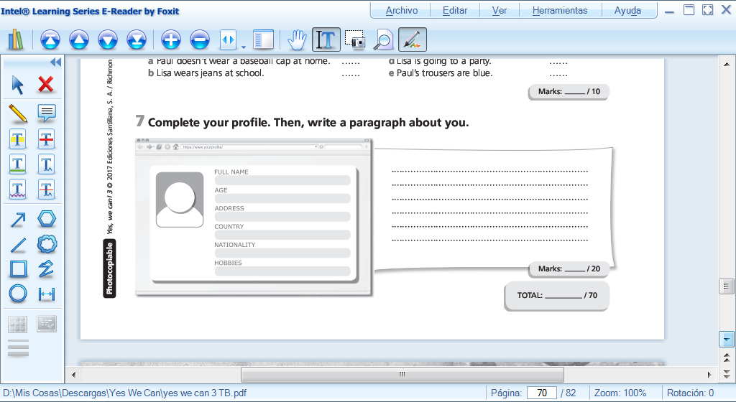
- CHOOSE A CLASSMATE AND WRITE ABOUT HIM / HER (Elije un compañero/a o amigo/a y escribe sobre el o ella)
- ACTIVITY 2
MATCH THE SENTENCES WITH THE PICTURES (Une las oraciones a las imagenes)
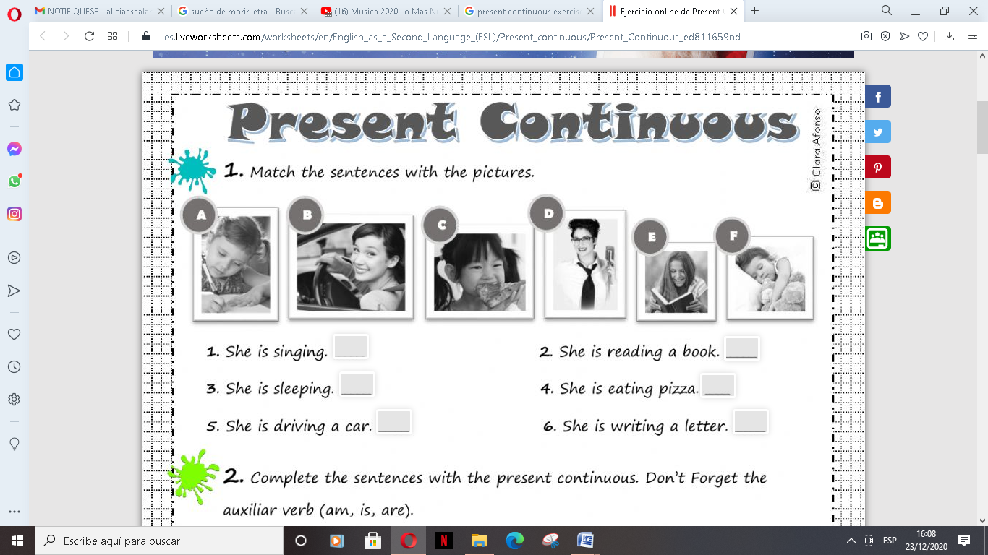
- ACTIVITY 3
COMPLETE THE SENTENCES WITH THE PRESENT CONTINUOUS (Completa con el presente continuo)
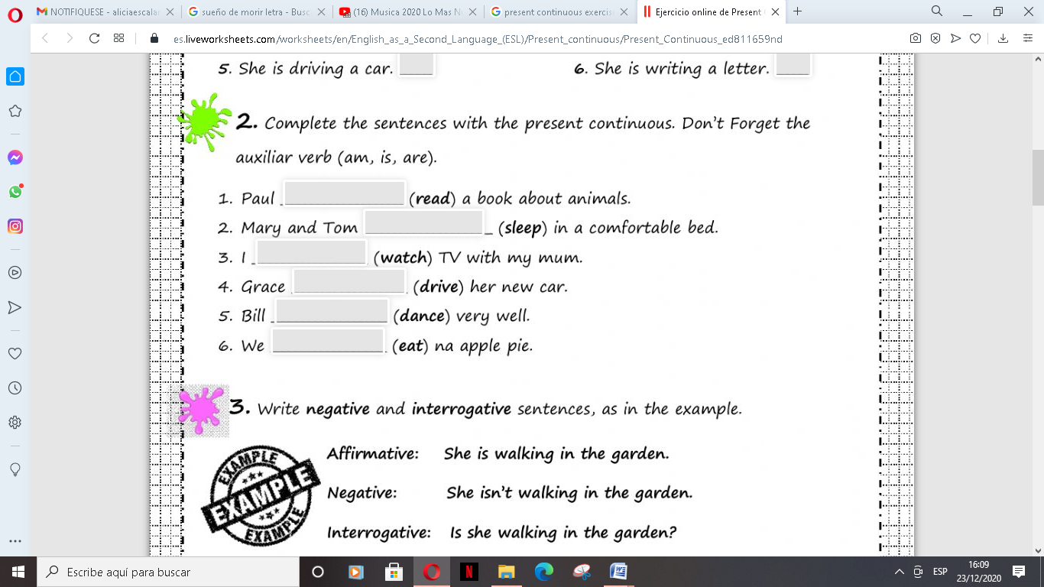
- ACTIVITY 4
WRITE NEGATIVE AND INTERROGATIVE SENTENCES. (Escribe la oracion negative y la interrogativa como el ejemplo)
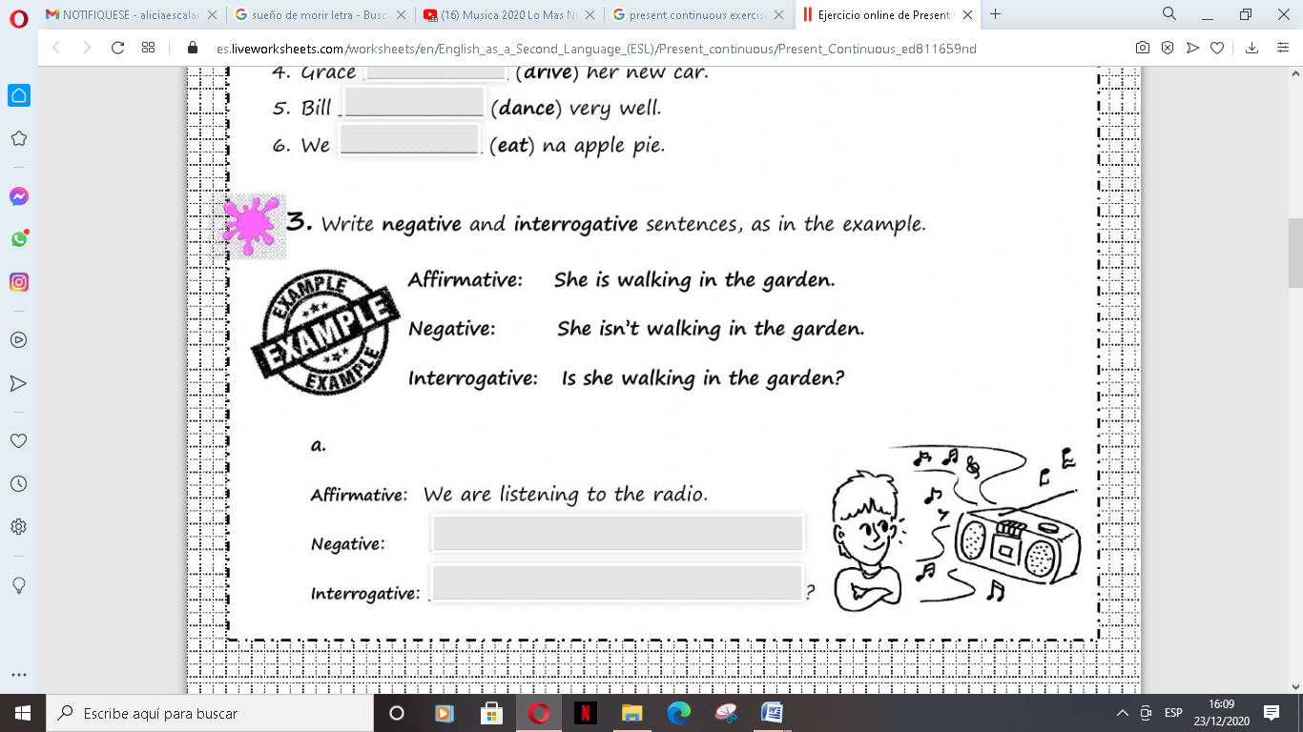
- ACTIVITY 5
PRESENT SIMPLE: CHOOSE THE CORRECT OPTION (Elije la opcion correcta)
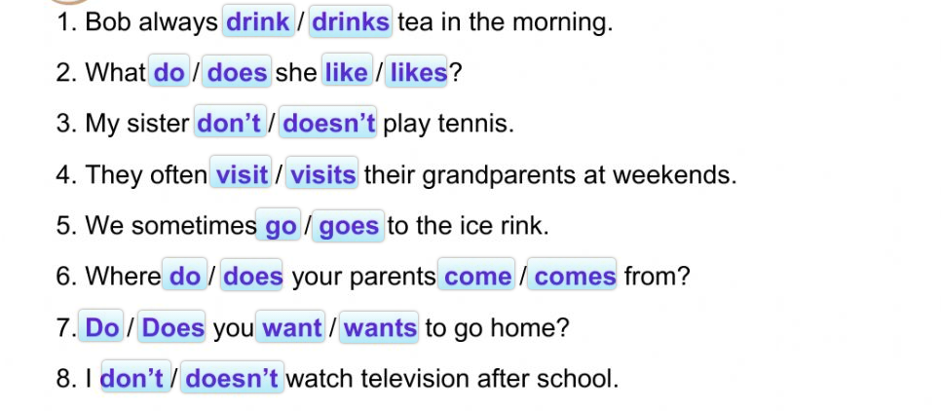
- ACTIVITY 6
COMPLETE THE QUESTIONS AND ANSWERS. (Completa las preguntas y respuestas)
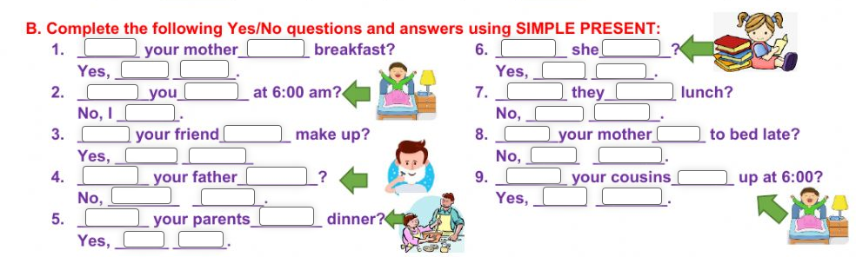
- ACTIVITY 7
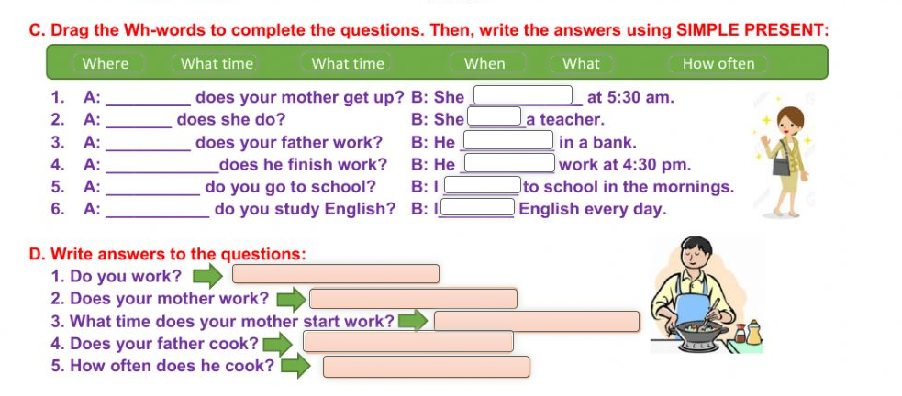
- ACTIVITY 8
READ THE TEXT AND WRITE “TRUE” OR “FALSE” (Lee el texto cuidadosamente. Escribe verdadero o falso y corrige las incorrectas)

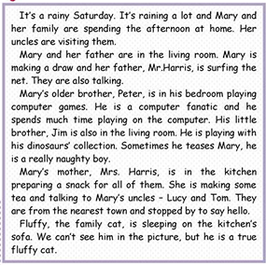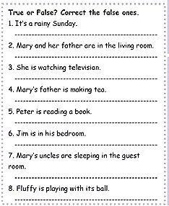
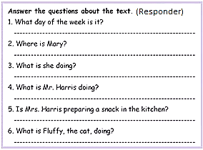
- ACTIVITY 9
WHAT ARE THE PEOPLE DOING? LOOK AT THE PICTURES AND WRITE SENTENCES. (Mira las imágenes y escribe oraciones)
EXAMPLE: 1) Tom and Emma / sunbathe Tom and Emma are sunbathing
2) Anne / play tennis _____________________________
3) Samy / ride a bike _____________________________
4) Bob / suf _____________________________
5) My brother / surf _____________________________
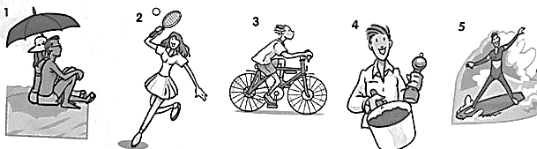

9) UNDERLIN
- ACTIVITY 10
THE CORRECT FORM OF THE VERB IN EACH SENTENCE. (Subraya la forma correcta)
A) I am working /work in an office every day.
B) She is visiting / visits her mother today.
C) I can't answer the telephone - I am taking / take a shower.
D) He is taking / takes a shower every morning.
E) I'm busy now. I am cooking / cook dinner.
F) They are watching / watch TV every afternoon.
G) Usually, he is riding / rides his bike to work.
- ACTIVITY 11
READ THE SENTENCES AND THEN WRITE THE NEAGTIVE AND INTERROGATIVE FORM. ( lee las siguientes oraciones y luego escribe su forma negativa e interrogativa)

        - My mother was at home last night.
        - My parents were good students.
        - My sister was a teacher.
        - The pencil was in the pencilbox.
        - Yesterday was Wednesday.
        - The students were at school yesterday.

a) My mother was at home last night. (+)
My mother wasn’t at home last night. (-)
Was my mother at home last night? (?)

