TRABAJO PRACTICO N°8-INTEGRADOR
TURNO: Mañana – Tarde - Vespertino
MATERIA: LENGUA EXTRANEJRA INGLÉS
CURSO: 5TO DIVISIÓN: TODAS
Semana: Del 23-9-20 al 30-9-20
INDICACIONES: Realizar el trabajo y enviarlo al correo del docente según el curso, turno y fecha de presentación. Una vez corregido por el docente imprimirlo o copiarlo en la carpeta de inglés.
NÚMERO DE CELULAR ALTERNATIVO EN CASO DE QUE LO NECESITES: 3875678400
Prof.: Ivana Taritolay Curso: 5º Div.: 1ª E-mail: ivanataritolay@yahoo.com.ar Turno: Mañana
Prof.: Alicia Escalante Curso: 5º Div.: 1ª E-mail: aliciaescalante95@gmail.com Turno: Tarde
Prof.: Cintia Morón Curso: 5º Div.: 1ª E-mail: cintiamn71@gmail.com Turno: Vespertino
Prof.: Cinthya Fernández Curso: 5º Div.: 2ª E-mail: veritocin77@gmail.com Turno: Vespertino

Datos a completar por el alumno
APELLIDO Y NOMBRE:
CURSO: DIVISIÓN: TURNO:
E-MAIL:
TELÉFONO: (SEÑALAR: FIJO O MÓVIL)

ACTIVIDADES PROPUESTAS
(Lee el texto cuidadosamente)


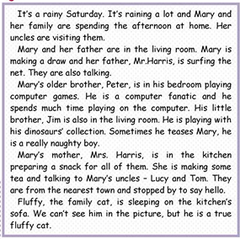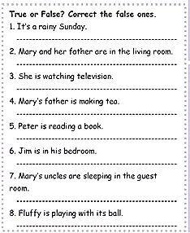
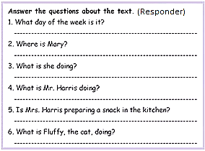

2) What are the people doing? Look at the pictures and write the correct short answer. (Mira las imágenes y escribe la respuesta correcta, usando respuestas cortas.
EXAMPLE: 1) Are they swimming? No, they aren't.
2) Is she playing tennis? _____________________________
3) Is he driving? _____________________________
4) Is he cooking? _____________________________
5) Are they surfing? _____________________________
6) Are they having a good time? _____________________________
7) Is she dancing? _____________________________
8) Are they running? _____________________________
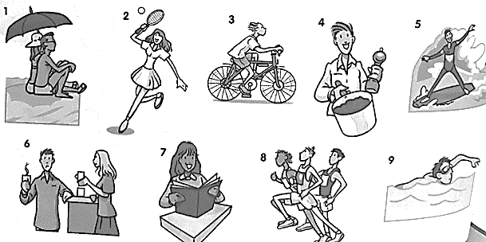
9) Is he swimming? _____________________________

3) Underline the correct form of the verb in each sentence.
A) I am working /work in an office every day.
B) She is visiting / visits her mother today.
C) I can't answer the telephone - I am taking / take a shower.
D) He is taking / takes a shower every morning.
E) I'm busy now. I am cooking / cook dinner.
F) They are watching / watch TV every afternoon.
G) Usually, he is riding / rides his bike to work.
H) Please don't interrupt us! We are talking / talk.
4) Complete the text with the correct simple present form of the verbs in parentheses. (Completa el texto con la forma correcta del presente simple de los verbos entre paréntesis)
My new study program (1)______________(be) great. I (2)________________(study) biology, chemistry, and math. Biology and chemistry (3)__________________(be) interesting, but I (4)_______________(not like) math. I (5)___________________(have) classes every day during the week, but I (6)___________________(not study) on the weekend. My roommate is named Lisa. She(7) __________________ (study) French and Italian. She (8)_________________(like) Italian, but she (9)___________________ (not like) French - she thinks it's difficult! On the weekend she (10)___________________(go) home to visit her parents.
5) Complete the table with the correct third person singular simple present forms. (Completa la tabla con la forma correcta de la 3ra persona del singular en presente simple)
Simple present | Third person singular
watch
study
go
walk
teach
cry
wash
read
like
do

