TP – RECUPERATORIO FEBRERO 2021
MATERIA: LENGUA EXTRANEJRA INGLÉS
CURSO: 5° DIVISIÓN: 1°
TURNO: Tarde
Nombre y Apellido del alumno/a: …………………………....... Curso y Turno: ……………..
FECHA DE PRESENTACION: SEMANA DEL 10/02/2021 AL 12/02/2021
FECHA DE DEFENSA ORAL DEL TRABAJO PRACTICO: : LUNES 22 DE FEBRERO DE 2021
LINK DE REUNION:
IMPORTANTE:
INDICACIONES: Realizar el trabajo y enviarlo al correo del docente según el curso, turno y fecha de presentación.
Prof.: Alicia Escalante Curso: 3° Div: 2ª E-mail: aliciaescalante95@gmail.comTurno: Tarde
- ACTIVITY1
ANSWER THE QUESTIONS (Responde las preguntas sobre ti)

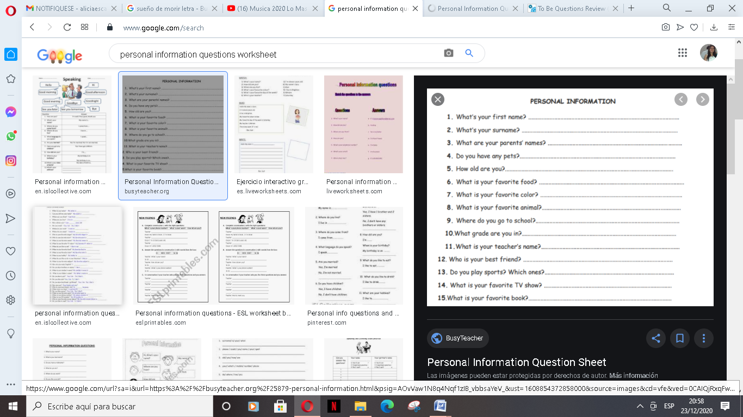

- ACTIVITY 2
NOW, WRITE ATEXT ABOUT YOU USING THE INFORMATION. (Ahora escribe un texto con la informacion de arriba)
……………………………………………………………………………………………………………………………………………………………………………………………………………………………………………………………………………………………………………………………………………………………………………………………………………………………………………………………………………………………………………………………………………………………………………………………………………………………………………………………………………..

- ACTIVITY 3
LOOK AT THE PICTURES AND COMPLETE THE SENTENCES. (Mira las imagenes y completa las oraiones)

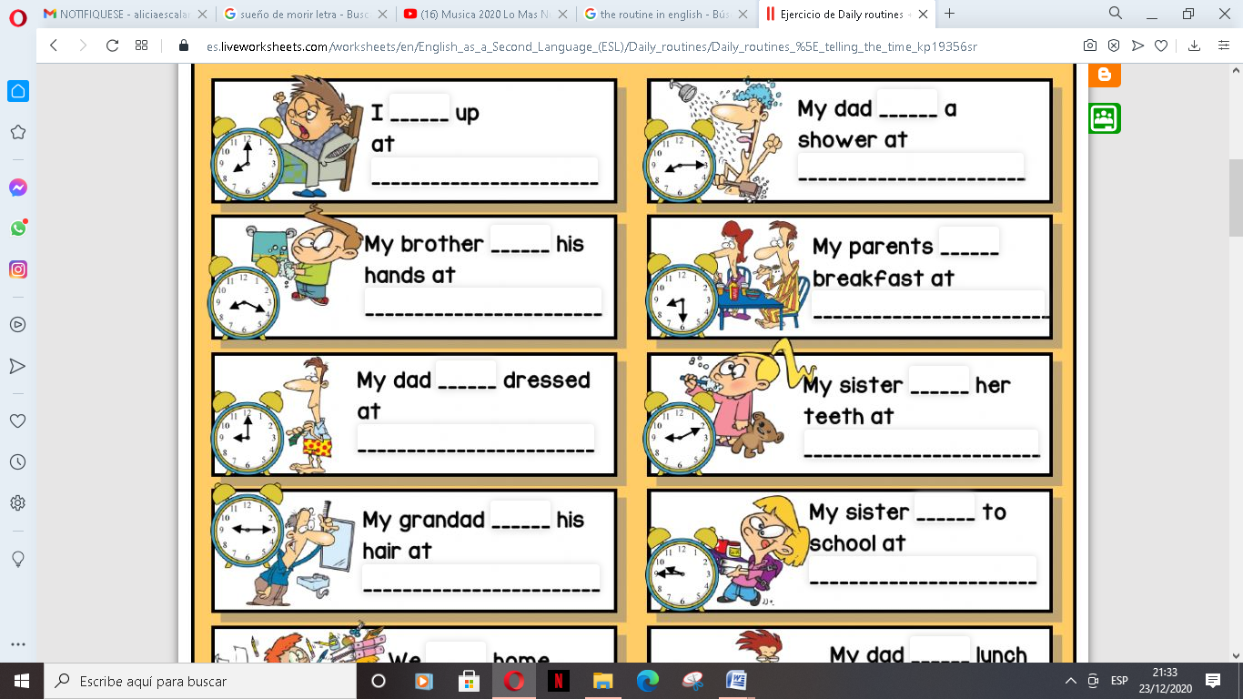

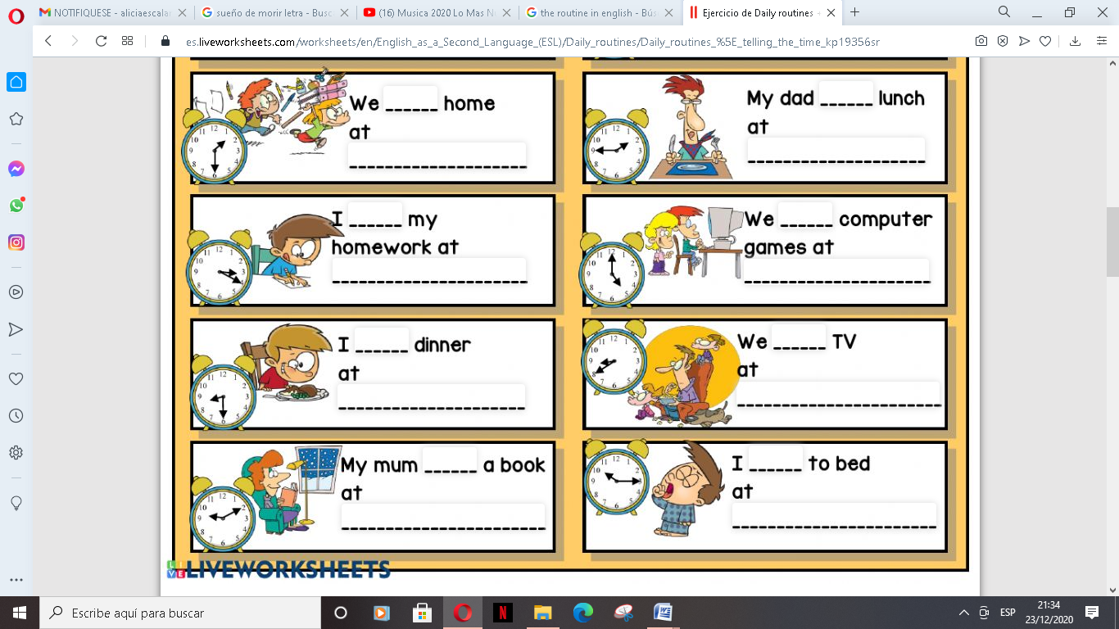

- ACTIVITY 4
CHOOSE 5 SENTENCES AND MAKE THEM NEGATIVE , USE DON’T / DOESN’T. ( Elije 5 oraciones y escribe su negativa)

- ……………………………………………………………………………….
- ……………………………………………………………………………….
- ……………………………………………………………………………….
- ……………………………………………………………………………….
- ………………………………………………………………………………..

- ACTIVITY 5

READ ABOUT SOPHIE (Lee la informacion sobre Sophie)
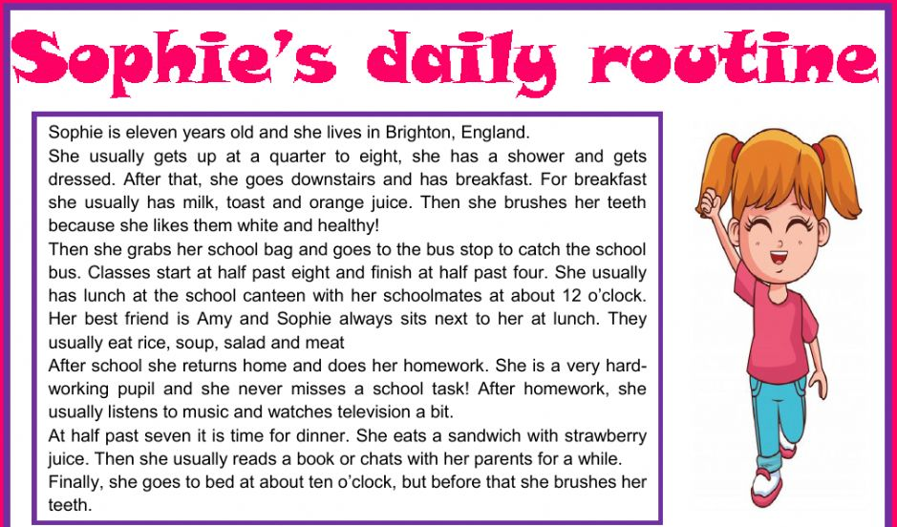

- Elije la opcion correcta B- Ordena la rutina de Sophie
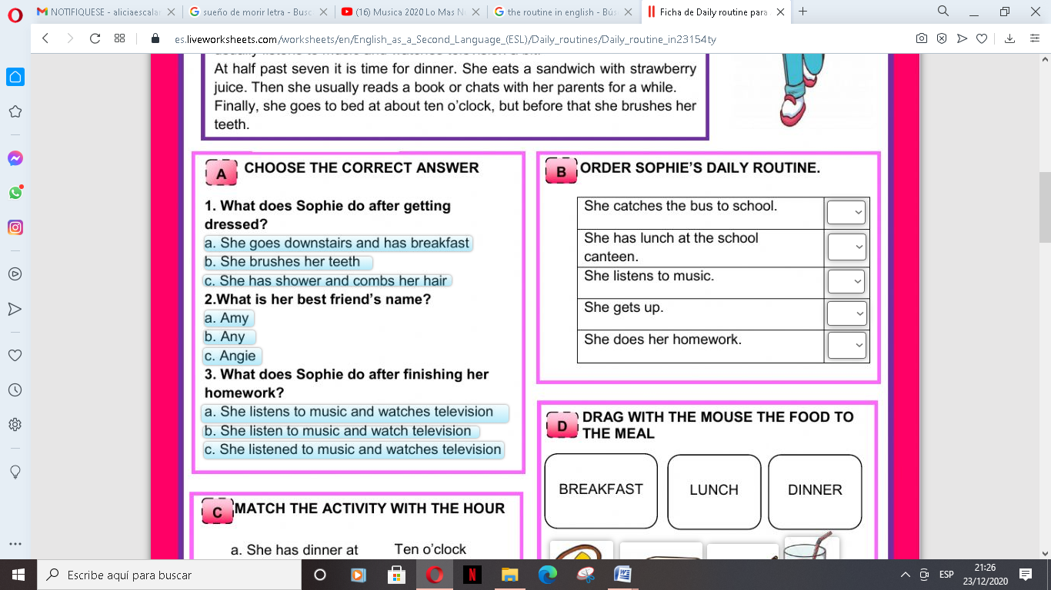

C-Unir la actividad con la hora
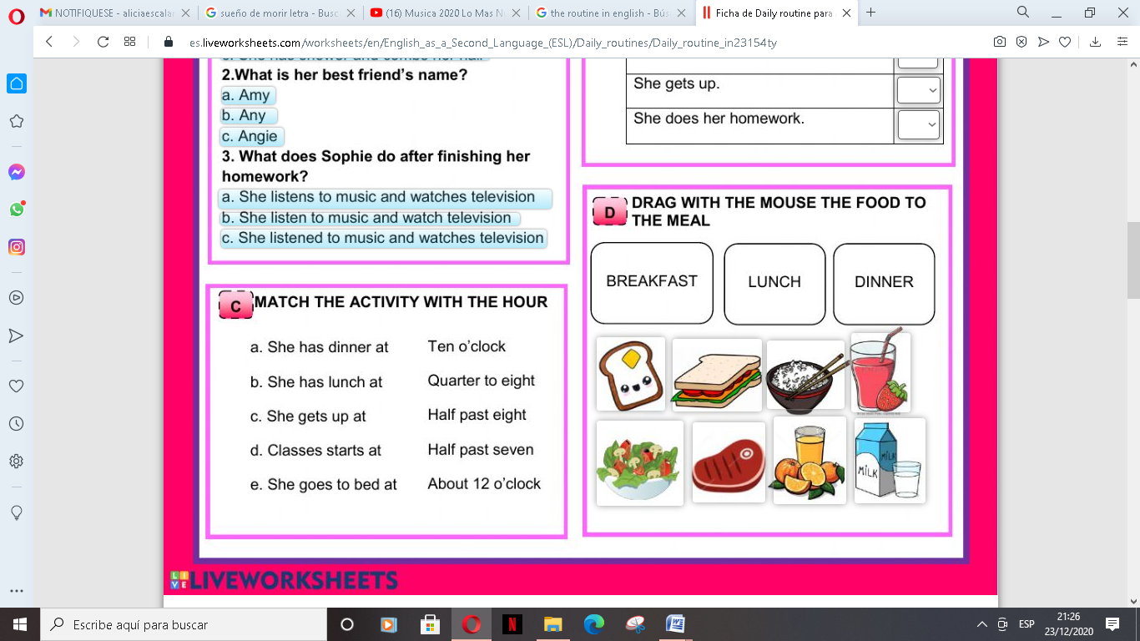

- ACTIVITY 6

Read the sentences and rewrite using the negative and interrogative ( lee las siguientes oraciones y luego escibe su negativa e interrogativa)
        - My father was a good student.
        - They were good friends.
        - My mother was an actress.
        - The English book was on the desk.
        - Yesterday was Monday.
        - Dani and Mary were at the cinema yesterday.

EXAMPLE:
a) My father was a good student. (+)
a) My father wasn´t a good student. (-)
a) Was my father a good student? (?)
Past time expressions
- ACTIVITY 7
A-COMPLETE THE SENTENCES WITH WAS / WERE B- REWRITE IN NEGATIVE
(Completa con WAS/WERE) (Rescribe en forma negativa)

a) I was with my parents in the mountains.
_____________________________________
b) Tim was absent yesterday.
______________________________________
c) Jim was at the bank yesterday.
______________________________________
d) My baby borther was born at 10:00 am
______________________________________

a) I ______ill last night.
b) Susan _______ on stage.
c) They ______ at Scholl last Tuesday.
d) Elvis Presley ______ American.
e) They _______ born in 1996.

- ACTIVITY 8
WRITE THESE SENTENCES IN ENGLISH. (Escribe las siguientes oraciones en Ingles)

- Yo fui un buen estudiante el año pasado. _________________________________
- Los alumnos estuvieron en la escuela en año pasado _________________________
- Estuvo soleado y caluroso ayer _____________________________
- La película estuvo interesante anoche _____________________________________
- Ellos eran buenos amigos hace algunos años _______________________________

- ACTIVITY 9
ANSWER ABOUT YOU (Responde sobre ti)

a- Were you at school last Friday? __________________________
b- Was it hot and sunny yesterday?____________________________
c- Was the COVID 19 Virus in Argentina last year? ___________________
d- Was the president of Argentina Mauricio Macri in 2019? ___________________
f-Were the football matches stopped in Argentina for the COVID19? _____________________
- ACTIVITY 10
WRITE THE SIMPLE PAST OF THE REGULAR VERBS. (escribe el pasado de los siguientes verbos regulares)
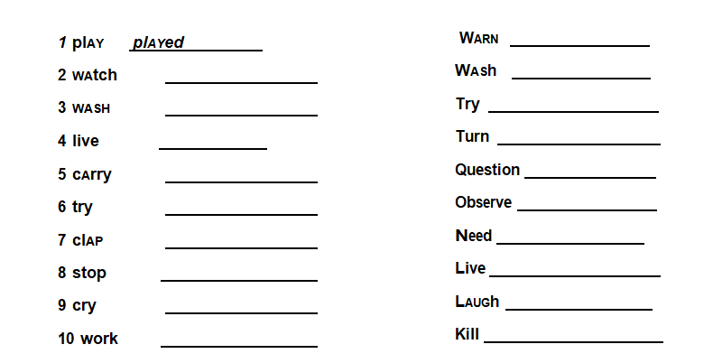
- ACTIVITY 11
ORDER THE SENTENCES (ordena las siguientes oraciones)
