DE LO PRESENCIAL A LO DIGITAL
TURNO: Mañana / Tarde / Vespertino
Materia: Lengua Extranjera Inglés
Curso: 4° (Todas las divisiones)
Semana: Del 30-3-20 al 3-4-20
INDICACIONES: Realizar el trabajo y enviarlo al correo del docente según el curso y turno hasta el día lunes 6 de abril de 2020. Una vez corregido por el docente imprimirlo o copiarlo en la carpeta de Inglés.

Prof.: Cintia Morón Curso: 4° Div: 1° e-mail: cintiamn71@gmail.com Turno: Mañana
Prof.: Alicia Escalante Curso: 4° Div: 1° e-mail: aliciaescalante95@gmail.com Turno: Tarde
Prof.: Noelia Vega Curso: 4° Div: 1° e-mail: vnoelia020@gmail.com Turno: Vespertino
Prof.: Noelia Vega Curso: 4° Div: 2° e-mail: vnoelia020@gmail.com Turno: Vespertino

Datos a completar por el alumno
APELLIDO Y NOMBRE:
CURSO: DIVISIÓN: TURNO:
E-MAIL:
TELÉFONO: (SEÑALAR: FIJO O MÓVIL)

ACTIVIDAD PROPUESTA
CLASS N° 2.1 (REVISIÓN DE INFORMACIÓN PERSONAL)
Introducing ourselves
Take a look at the following cards
In this part you are going to talk about you and others (he, she)
Can you remember how to answer all these questions? What does “SPELL” mean?
In case you don’t remember: we use it to tell the other person how our name or surname must be written.
Eg: I spell my surname: (M)em- (O)ou- (R)ar- (O)ou-(N) en
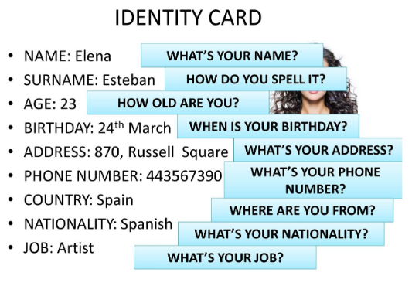

Activities:
- Answer the questions as if you were Elena. (eg: My names is Elena) (Responde las preguntas)
- Read the following card and answer about Catherine. Use SHE, HER (eg: Her name is Catherine)
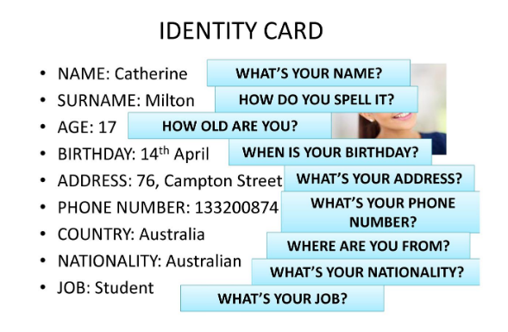
- Now read about Joao and answer the questions about him. Use HE, HIS (eg: His name is Joao)
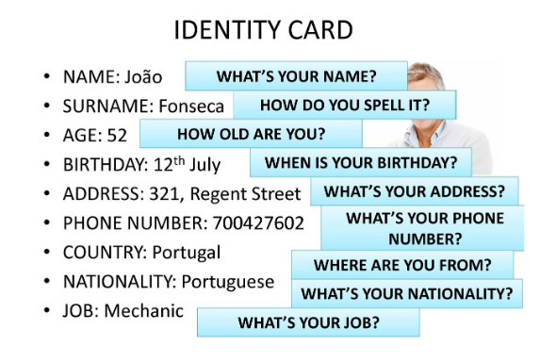
- In this activity you will watch a video.
- Listen and take notes about the two girls´ information (escucha y toma nota sobre los datos de las dos chicas según las preguntas que les hacen). Then go on watching and check (luego continua viendo y revisa si las notas que tomaste son las correctas.
- After checking your notes, you will be able to make the questions for the answers on the screen. (después de checkear tus respuestas, la siguiente actividad consiste en que Tú hagas las preguntas para las respuestas que te muestran en la pantalla). Record yourself and send the audio or video via email (graba un audio o video y envíalo por correo).

GOOD LUCK!!!

https://www.youtube.com/watch?v=cpRA8rjtass

CLASS N° 2.2 (REVISIÓN DEL VERBO TO BE)
Basic Verbs Review
Verb TO BE: this verb means “SER” o “ESTAR”. It has three forms AM, IS, ARE and it changes its form according to the subject we use.
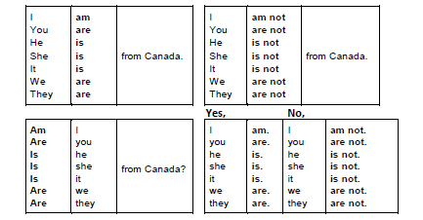
AM is used only with I; IS is used with singular nouns or subjects (in this case SHE, HE, IT); and ARE is used with plural nouns or subjects (WE, YOU, THEY)
Activities
- Write the correct form of "TO BE" in present tense.
My name (be) ________(1) John. I (be) ________(2) fifteen years old. I live on a farm. It (be) ________(3) in the country. It is quiet in the country. It (be, not) ____ ____(4) loud in the country. I wake up early. Sometimes, I wake up before the sun rises. Sometimes, it (be) ________(5) still dark when I wake up. But I don’t mind. I like waking up that early. I like the way the country looks in the morning. The first thing I do after I wake up is milk the cow. After I (be) ________(6) finished milking the cow, I bring the milk to my mom. I think she uses it to make breakfast. She makes a delicious breakfast. My mom (be) ________(7) a really good cook. Next, I feed the pigs. One time, I asked my mom how come my little sister doesn’t feed them. She said it is because my sister (be, not) ____ ____(8) strong enough. But I still don’t understand. She is almost as strong as me! I guess my mom doesn’t want my sister to get hurt. After all, the pigs can (be) ________(9) pretty rough, especially when they (be) ________(10) hungry. The last thing I do (be) ________(11) feed the chickens. That (be) ________(12) easy. I just throw some food down on the ground and they run out and eat it. While the chickens (be) ________(13) eating, I go into their house to collect their eggs. Chicken eggs (be) ________(14) really good to eat. They (be) ________(15) easy to cook too. That is what I do in the mornings. I (be) ________(16) pretty busy.
Verb HAVE GOT: this verb means “TENER”. It has two forms HAVE GOT or HAS GOT and it changes its form according to the subject we use.
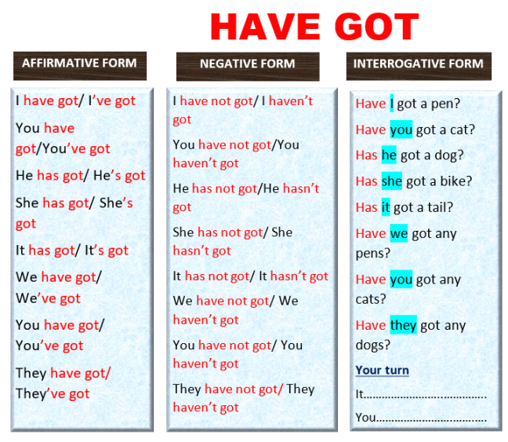
HAVE GOT is used only with I and plural nouns or subjects (WE,YOU,THEY); HAS GOT is used with singular nouns or subjects (in this case SHE, HE, IT)
2- Correct the mistakes in these sentences.
1. He is green eyes.
2. We got have two dogs and a cat.
3. She got a brother and a sister.
4. They no have got any chilli peppers.
5. Have Daisy got a boyfriend?
6. We have got not many ideas.
7. Has you got the time?
8. He has a pencil?
Verb CAN: this verb means “PODER”. It has one form. The same form for all the nouns or subject pronouns. It is always followed by another verb (eg: I can speak English and Spanish)
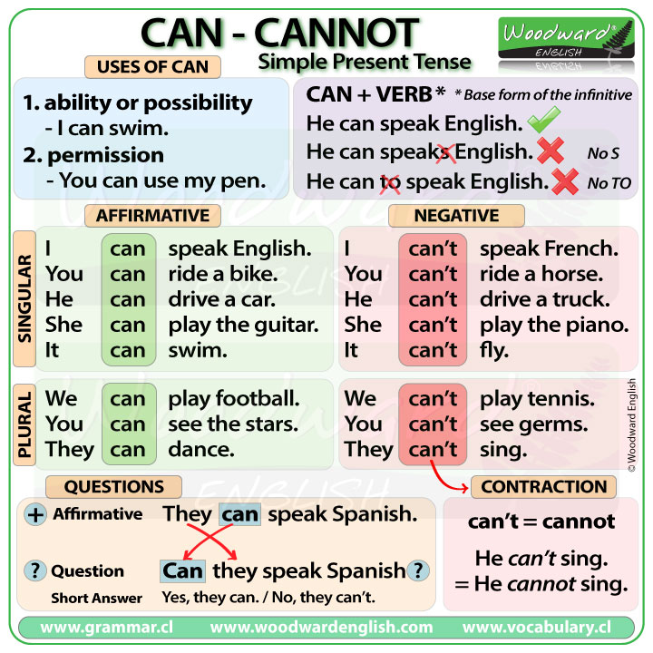
3- Choose the correct endings from B to complete the sentences in A.
A
Let's go on a trip. ..........................................................................................................................
She is so different. ........................................................................................................................
My phone bill is so big. ................................................................................................................
Do you know Greg's address? ......................................................................................................
Yes, she is over there. ..................................................................................................................
Your rucksack is so heavy. ..........................................................................................................
I speak Spanish. ............................................................................................................................
Alison has a camera. ....................................................................................................................
I know that the soup isn't very good. ...........................................................................................
You are lying to me. .....................................................................................................................

B
It can't be true.
I can't pay it.
We can see her.
She can't be your sister.
I can't remember it.
We can rent a car.
She can take a picture of it.
You can't carry all that.
I can translate it for you.
I can't cook.
You did a GREAT JOB!!!!
CLASS N° 2.3 (REVISÓN DEL PRESENTE SIMPLE)
Welcome back!! Today we are going to do some Reading first.
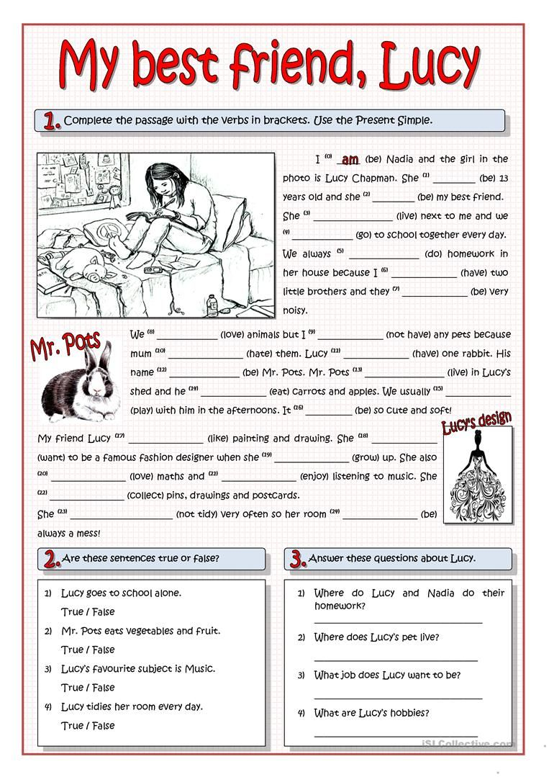
- Are these sentences TRUE or FALSE?
- Lucy goes to school alone. ___________
- Mr. Pots eats vegetables and fruit. __________
- Lucy´s favourite subject is music. _________
- Lucy tidies her room every day. __________

- Answer these questions about Lucy.
- Where do Lucy and Nadia do their homework?
- Where does Lucy´s pet live?
- What job does Lucy want to do when she grows up?
- What are Lucy´s hobbies?
This text is in the Present Simple Tense. Was it easy? Do you remember something about the Present Simple Tense?
Check this link to read about the Present Simple Tense
https://www.slideshare.net/iraidahj/simple-present-tense-10194657
Here are some routine verbs
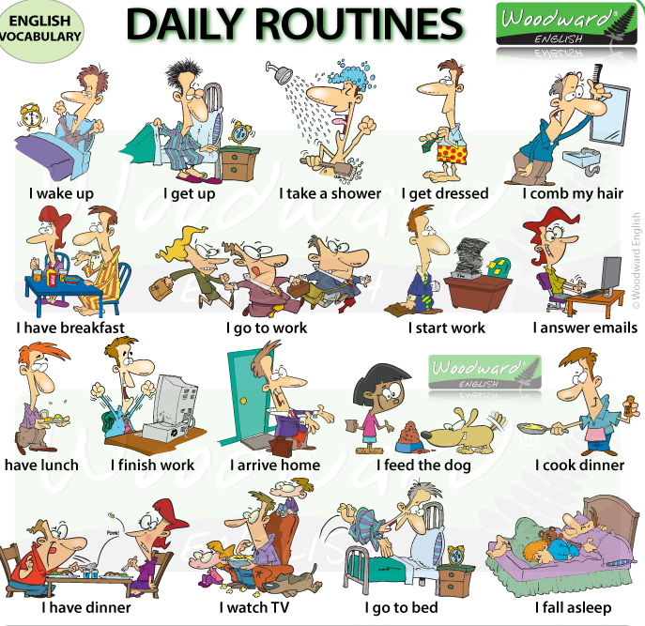
What about the time? Do you remember how to write the time in English? (¿Recuerdas como decir la hora en Ingles?)
https://www.youtube.com/watch?v=fq2tRfHu5s8&t=12s
BE CAREFUL!!!! In English we DON´T use the 24 hour system, we use the 12 hour system, so you CAN´T say:
13.05 it´s five past thirteen (this is incorrect)

13.05 it´s five past one (this is correct!!)
- Can you try telling the time?
Here you have a PDF document to click on and do some exercises on the time.
http://agrupcadaval.com/moodle20/pluginfile.php/8964/mod_resource/content/1/WHAT_TIME_IS_IT%20%281%29.pdf

Activities
Now let´s try some more exercises
- Write your routine. Choose a day and write about it. Use adverbs of frequency and the time (10 sentences).
_________________________________________________________________________________________________________________________________________________________________________________________________________________________________________________________________________________________________________________________________________________________________________________________________________________________________________________________________________________________________________________________________________________________________________________________________________________________________________________________________________________________________________________________________________________________
- Now complete the sentences with the correct form of the verb in the Present Simple.
- What __________________ the longest river in the world? (be)
- The longest rivers __________________the Amazon and the Nile. (be)
- What __________________ in your free time? (do)
- I __________________anything. I just get bored. (not do)
- Mrs Jolie, your son __________________ in my lessons. (sleep)
- Oh, no. How long __________________? (sleep/he)
- __________________ this your bag? (be)
- No, it __________________mine. (not be)
- What about your children? __________________ to the same school? (they/go)
- Annie __________________ to school. She is four. (not go)
- Sue and Kam __________________ well-dressed today. (be)
- Are you crazy? They __________________well-dressed at all! (not be)
- __________________your husband a good driver? (be)
- Well, he always __________________ his best. (try)
- Greg is the best player in our team. He never __________________ the goal. (miss)
- Really? How often __________________? (he/score)
- I think I __________________ quite good at English. (be)
- Why __________________so? (you /think)

- Finally, listen to the song and fill in the spaces with the missing words.
https://www.youtube.com/watch?v=acvIVA9-FMQ&list=PLtK6rr2ahr7UEmCd0kBscbynYKuyF_4Fj&index=3&t=0s
LUCKY
Jason Mraz
_________ you hear me? I'm talking to you
Across the water across the deep blue ocean
Under the open sky, oh my, my baby I'm trying
Boy, I hear you in my dreams
I___________ your whisper across the sea
I ________ you with me in my heart
You ________ it easier when life ________ hard

Lucky I'm in love with my best friend
Lucky to have been where I have been
Lucky to be coming home again

They ________ ________how long it ________
Waiting for a love like this
Every time we ________ goodbye
I wish we had one more kiss
I'll wait for you, I ________ you, I will

Lucky I'm in love with my best friend
Lucky to have been where I have been
Lucky to be coming home again
Lucky we're in love in every way
Lucky to have stayed where we have stayed
Lucky to be coming home someday

And so I'm sailing through the________
To an ________ where we'll meet
You'll hear the music fill the air
I'll put a ________ in your hair
Through the breezes through the ________
Move so ________you're all I see
As the world________spinning round
You ________me right here right now


Click here to check your answers and sing along….!!!
https://www.youtube.com/watch?v=zXl2eNYfMr8

